Peterborough Examiner

Not Russian, not mobsters, but a man died and label stuck
By Lubomyr Luciuk
Friday, November 9, 2012 10:46:18 EST AM
The newspapers dubbed them “the Russian Gang.”
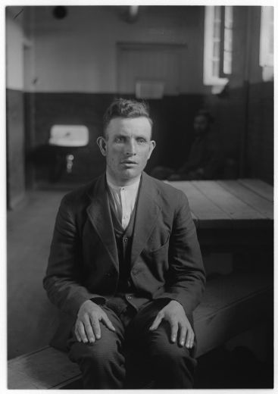
But they weren’t Russians.
Their names were Michael Bahry, Thomas Konyk, Alexander Martiniuk, Filip Rotinsky and Sam Zalusky. Three came from Ukrainian lands east of the Zbruch river border, two from its west bank, so some carried passports issued by the Tsarist Russian Empire, while others were subjects of Austro-Hungary. All were Ukrainian by nationality.
These geopolitical details mattered once the First World War broke out, in August 1914. Imperial Russia was an ally of the British Empire while the Austro-Hungarian monarchy stood with Germany. So “Austrians” were branded as “enemy aliens,” and suffered internment, disenfranchisement, and other indignities.
As the Office of Internment Operations archives are incomplete we don’t know what happened to every member of the “Russian Gang” between 1914 and 1919. It’s not hard to imagine each of them falling victim to the virulent anti-foreigner prejudices of those days. In Bahry’s case he appears to have been arrested as an “enemy alien,” age 15, held first in a “receiving station” set up in Montreal’s federal Immigration Building, from where he was transported to Valcartier and, in April 1915, on to a larger internment camp at Spirit Lake, in Quebec’s remote Abitibi region. In June 1916, Bahry was paroled into the custody of Lane Brothers Limited, as a labourer on the Welland Canal. We know this detail because a man called Nikolas, who claimed to be his father, and who had also suffered internment, at Petawawa and later in Kapuskasing, tried to claim Michael’s possessions on 22 April 1920. How father and son were separated is not known, nor is what happened to Nickolas thereafter. No Bahry descendants have been located.
What we do know is that on the night of 22 June 1919 the “Russian Gang” liquored up, donned masks, and raided a bunkhouse near a quarry owned by the Canadian Rock Company, just outside Havelock, Ontario. One robber, Konyk, was carrying a loaded pistol. It discharged and a Macedonian worker, Philip Yanoff, was hit, bleeding to death as the thieves made off with about $100. They didn’t get far.

Tried and found guilty, Martiniuk, Rotinsky, and Zalusky got life in Kingston Penitentiary. Bahry and Konyk received death sentences.
Nine clergymen appealed to the Minister of Justice, Dec. 8, 1919, reporting that “confidential interviews with the condemned men” left them convinced “no murder was intended,” that the shot fired was “accidental,” that these young men were “possessed of a spirit of deep contrition.” While not wishing “for a moment [to] lose sight of the fact that great care is being taken by the government in dealing with the restlessness of the country and its cause,” nor to “minimize the danger and menace of the foreigner,” they pleaded for the prisoners’ lives, beseeching the Minister to deport them: “As a great Nation we can afford to spare life.” Their prayer was rejected, as was a last-minute telegraphed plea from Konyk’s lawyer, Mr. P. T. Ahern, who affirmed his client was holding the gun when it went off, that Zalusky – not Bahry – was the ringleader, remonstrating that these facts warranted sparing Bahry his meeting on the morrow with the hangman. It was not to be.
A double execution was carried out in the Peterborough County Jail, 14 January 1920, Ukrainian New Year’s Eve on the Julian calendar. Arthur Ellis, one of Canada’s most notorious hangmen, presided. The scaffold’s cross beam, constructed of weather-beaten timbers resurrected from the jail’s store room, could be seen just above the prison walls, the Peterborough Daily Review reporting how this “gruesome spectacle” had “attracted a number of the morbidly curious.” Following their judicial execution the felons were laid in coffins, heads to the west, conforming to an old belief that when our Saviour returns it will happen in the east, the geography of their placement allowing the dead to walk toward Him at the Second Coming.
Until August 1994 Michael and Thomas were all but forgotten, disinterred during an archaeological survey conducted 80 years after the Great War began. Their skeletons were removed to the University of Western Ontario, examined carefully, learned papers penned about how they met their ends through the “long drop,” the mechanics of which would “not have necessarily resulted in instantaneous death in all cases [although] unconsciousness was probably immediate.”
When we discovered what befell these “enemy aliens” we passed no judgment on how others, long before our time, decided their fate. Yet we were determined to give these two young men, convicted criminals if you will, shelter in hallowed ground, for that is a Christian duty.
Before they were hanged Konyk and Bahry were photographed, and Michael received a bouquet from the Ladies Guild of St John’s Church, prompting his final words: “These are the last flowers I will ever see in my life.” So as we lowered them back into the earth on Oct. 13 we placed flowers on the simple boxes that now shroud them. At that very moment a preternatural silence descended upon Ottawa’s Beechwood National Cemetery, interrupted only by the singing of two birds, perched somewhere nearby. Responding to them our small company sang a Ukrainian dirge, “Do you see, my brother?” Written in 1910 it would have been a melody familiar to Bahry and Konyk, its mournful words evoking the metaphorical image of the cranes that migrate annually out of Ukraine, many fated never to return, to instead die in foreign lands, far away.
Bahry and Konyk will now rest in peace until that final Day of Judgment that awaits us all.
Lubomyr Luciuk is a professor at The Royal Military College of Canada.

