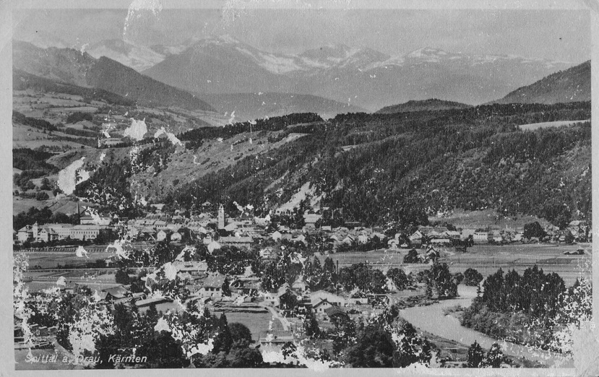
Description of Stalag 18A

Stalag 18A/Z was located at Spittal an der Drau to the North-West of Klagenfurt and Villach. It was originally designated Stalag 18B. Initially there were two camps: a Transit Camp for POWs being moved from one area to another, and a Lazaret (hospital) which catered for sick or injured POWs. The photographs shown below may have been taken at the Camp or at the Lazaret. The same applies to the POW names. To give some idea of chronological order I have amalgamated extracts from a number of Red Cross reports.
The following description of Stalag 18A/Z comes from 'The War Story of Soldier 124280' by Mike Sadler, L/Bdr, 26th Fld. Rgt. South African Artillery. Mike had been captured in North Africa and a POW in Italy before being transferred in 1943 to Stalag 18C at Markt Pongau and then, shortly after, to 18A/Z.
Next morning we found ourself in a wide green valley, south of Markt Pongau and close to the Yugoslav border, in Stalag 18A/Z, in a town called Spittal. This was the main POW camp for Austria and was very large. (At that point Mike was obviously not aware of Stalag 18A at Wolfsberg.) There was a Transit Camp, a military hospital and a permanent camp for Allied prisoners. The Transit Camp was large and held, not only newly arrived British and Commonwealth soldiers, like ourselves, but also men of many other nationalities. such as Russians, Slavs, Czechs, Hollanders, Frenchmen and Italians but, in a sense, they were not prisoners of war. They were men who had been taken from different countries occupied by Germany. They had been brought to this camp to be registered and then would be sent to different work camps. So, on arrival, we had to complete forms and be registered as Allied Prisoners of War. We
- 2 -

were then issued with a double rectangular Identity Tag which we were told to wear on a string round our necks so that, if we died in camp, one section would be detached and sent to the Red Cross as proof of death, and the other section would be buried with our bodies. Cheerful thought, that.
We spent two days in the Transit Camp getting sorted out and were then sent across to the Permanent Camp, in which only Allied Prisoners of War were kept. It was a large camp, divided up into four different sections with a fenced off road in the centre. The entrance gate led into the usual sorting area, except that this one also contained a kitchen and, what looked like dining hall, but we later discovered that this was only used for concerts and church services. Having been counted in the entrance area, we then passed through another gate into a fenced off roadway that ran down the middle of the compound. The main camp was on the left of the road, a smaller one on the right and a separate area fenced off at the bottom of the road. In each section there were wooden barracks, eight in the main camp and two in the smaller one on the right into which we were herded.
History of the 18 A/Z Stalag
Stalag 18A/Z History
November 1942
Camp
Man of Confidence: Sgt H. Kaplin
Camp Officer: Major Graf Leiningen
German Doctor: H. Fasan
British Doctor: Capt. Andrea Mikellides, RAMC (+ 3 Medical Orderlies)
Padre: G. Rex Morgan, R.A.Ch.D.
POW Strength: 209
Little coal is available and winter is setting in. Only one hot shower a week is available. Men coming in from Work Camps are often in worn-out uniforms. At least 400 uniforms are needed.S Rev. Morgan is still having problems with the camp authorities who would like to have him transferred but the POWs are supporting him.
Only minor cases are treated in the Infirmary; the rest go to the Lazaret. Capt Mickelledes wishes a transfer as he only has minor medical work to do heare.

- 3 -

Lazaret
Medical Officer: Capt. Ian McD. G. Stewart (Stuart?), RAMC
German Doctor: H. Fasan
Surgeon: Serbian (name unknown)
6 Medical Orderlies
3 Dentists
80 British patients
The medical equipment in the lazaret is very good. It is possible to carry out every surgical intervention. The Serbian surgeon is very efficient and clever. There is no civil hospital available. The drug supply is sufficient and there are some facilities for dietary treatment. There is no sign of vitamin deficiency but some of iron deficiency. The dentists are short of dental material. Dental treatment is free.
January 1943
Camp
Man of Confidence: Sgt H. Kaplin
POW Strength: 100 (41 English, 30 Australian, 20 NZ)
Since the new Stalag 18B was created, this camp is the equivalent of a large Work Camp. German administration is carried out by one officer and a Paymaster. The camp would have been done away with were it not for the nearby Lazaret. About 100 POWs a month pass through the camp and Lazaret. They are allowed to recover their health, morale and equipment before being moved on. The buildings of the old Stalag 18B are being used to accommodate POWs elegible for repatriation, who were once at Stalag 18D. 20 NCOs arrived in May 1942 and will shortly be transferred to Stalag 3C. About 600 men (100 permanent occupants, 100 in transit, 400 in nearby Work Camps) are dependent on this camp.
The camp contains about 10 tons of bulk food and 9 tons of Red Cross parcels (5kg each). The coal ration (1.4kg/day/head) is inadequate.
Lazaret
Medical Corps: 40 (12 British + 1 Chaplain)
7 Doctors (2 British)
293 patients (34 British)
Camp comprises 4 large huts each divided into rooms holding 20-40 patients.

- 4 -
May 1943
Camp
Man of Confidence: Sgt H. Kaplin
Camp Officer: Oblt. Gatternik
Padre: Capt. I.B. McIver (NZ)
POW Strength: 201
A nearby camp is to accommodate 400 NCOs (probably from Stalag 18A).
Lazaret
M.O: Capt. Stewart
Padre: Capt. J.C. Hobling
48 British patients
August 1943
Camp
Camp Leader: D.C. Roper, 5240
POW Strength: 664 (362 British)
The whole camp (excluding the Lazaret) is to be transferred to the eastern side of the camp. (Presumably this became the Ostlager.) 32 Medical Orderlies want a transfer to Stalag 8B.
Lazaret
Camp Leader: Sgt I.C. Edmundsen, 5032
M.O: Capt Stewart
November 1943
Camp
Chief MOC: Sgt H. Kaplin
Camp Officer: Oblt. Gatternig
Abwehr Officer: Haupt. Hartang
Ostlager MOC: W.O. A.G. Johnston
Padre: Capt McIver
POW Strength: 874 British
Ostlager - 416 (used for POWs from Italy)
Westlager - 312
Lazaret - 138
In September 1943, about 4200 British POWs passed through this camp in transit from Italy to Germany.
- 5 -
Lazaret
Senior M.O: Capt W.W. Gunther, AAMC
MOC: Sgt W.T. Dear, 7356
German Doctor: H. Fasan
138 patients plus medical staff
June 1944
Camp
MOC: Sgt H. Kaplin
POW Strength: 185 (94 British)
During the last few days the POW strength has decreased as 200 NCOs have been transferred to Stalag 18C. The camp has a small theatre and an orchestra.
Lazaret
M.O: Capt O.V.S. Kok, 9546 (South Africa)
MOC: Sgt W.T. Dear
German Doctor: H. Fasan
Medical Staff: 9 Doctors (2 British), 23 Medical Orderlies (11 British)
323 patients (81 British)
From October 1944, The Red Cross reports refer to Spittal Hospital rather than the Lazaret. The description is of a building on the outskirts of Spittal rather than a camp.
October 1944
Camp
MOC: Sgt H. Kaplin
Hospital
M.O.s: Capt O.V.S. Kok, Capt E. Lewings, 31588 (Australia)
MOC: Sgt W.T. Dear
Medical Staff: 28 (17 British)
234 patients (60 British)
Unfit for service: 100 (28 British)
The hospital is in the suburbs of Spittal near to a railway.
February 1945
Hospital
M.O.s: Capt O.V.S. Kok, Capt E. Lewings, 31588 (Australia)
MOC: Sgt W.T. Dear
253 patients (102 British, 29 American)
A lot of British and American recently wounded in Italy are being treated. About 20 American and British wounded have arrived from the Western front.

